# **PROJECT DETAILS**

# **Complete the following table with respective project details (copy-paste as appropriate from last report):**

|  |  |
| --- | --- |
| Project ID | 4081 |
| Project Name | GTM Comprehensive Medical and Rehabilitation Project |
| Project Location | <Butajira,SNNPR,Ethiopia > |
| Project Duration | 1/1/2021-31/12/2023 |
| Total approved budget amount (in EUR) | < 55,303.73 > |
| Total budget expenditure amount (in EUR) | < 20,618.52 > |
| Contract Partner | <Grarbet Tehadiso Mahber > |
| Other Implementing Partners | <None > |
| Responsible person at Partner / Project | <<Mr.Tehsome Tulu,Mr.Desalegn Amanuel,Prof. Redda TekleHaimanot > |
| Date of report submission | < 15/7/2022> |
| Responsible person at CBM | <Samuel Bekele, programme Officer> |

1. **NARRATIVE REPORT**

# **Summary of Results Achievements**

**Result 1: Quality eye care services provided**

Grarbet Tehadiso Mahber (GTM) is dedicated to providing high-quality eye care services to the beneficiaries in the rural central Ethiopia who have limited access to such services. The comprehensive and inclusive eye care services encompasses prevention, curative, and promotion of overall eye health. GTM recognize the importance of accessibility and affordability in ensuring equitable eye care for all. In this regard, our field team at Buajira and Batu Centers work closely with governmental bureaus, non-profit organizations and community to extend our reach beyond our center’s wall. As a result of the eye care services rendered, patients are able to be cured from blinding eye diseases. Furthermore, preventive measures also identified and managed preventive blindness.

**Result 2: Essential ENT services provided to rural people in central Ethiopia**

GTM continued providing essential ENT services with emphasis on ear and hearing care during the reporting period. Furthermore, GTM integrated the ENT services to its eye care program as it can improve the uptake of the services. Any patients with ear and hearing issues are being referred to the GTM Butajira Centre by the mobile eye care team, which offers eye care services at the village level. As there is no any governmental facilities in GTM catchment area that provide ENT services, the beneficiaries are very much appreciated the service they received. The beneficiaries were screened and treated at the GTM base center in Butajira for acute and chronic otitis media as well as common ENT problems. As a result of the ENT and hearing Care provided, patients were cured from Ear and hearing difficulties. Furthermore, GTM organized surgical camps for patients who required advanced surgical intervention in close collaboration with Dr. Uta Froeschl of CBM and St. Paul's Hospital Millennium Medical College (SPHMMC). SPHMMC residents received hands-on surgical training during the surgical camp.

**Result 3: Locomotors rehabilitation services provided to persons with disabilities**

Persons with disabilities face many barriers to participate in all aspect of society. GTM have improved the quality of life for people with disabilities by providing medical, surgical as well as locomotive assistive devices. This created opportunity for beneficiaries to become self-sufficient and productive. Moreover, awareness of the community towards physical disability were improved.

**Result 4: Medical services provided to patients with Epilepsy in rural central Ethiopia**

One of the leading causes of neurological morbidity in the central rural Ethiopia is Epilepsy. Within its center in Butajira, GTM operates an Epilepsy clinic that is run by a qualified Health Officer. Persons with Epilepsy are diagnosed, treated and continuously followed at the center. The Health Officer consults a neurologist (Prof. Redda) on complicated cases. Persons with Epilepsy able to lead normal and productive life after their neurological problem was properly managed using very affordable antiepileptic drugs (AED).

# **Narrative Reporting on Activity Implementation**

* Which activities were planned to be implemented in the first six months (Q1 and Q2)? Please list down the Activity Name and Number only.
* Using the list above, please report on the activities implemented during the last 6 months. Describe if any targets were achieved or explain any variance in achieved versus planned activities in the reporting period. Explain who the main beneficiaries/ participants were.

**List of activities implemented during the reporting period**

**Result 01: Quality eye care services provided**

* 1. Eye patients screened and treated
  2. Active Trachoma cases treated with TTC
  3. Lid surgeries performed
  4. Cataract surgeries performed
  5. Adults and children refracted
  6. Adults and children educated

**Result 02: Essential ENT services provided to rural people in central Ethiopia**

* 1. Patients screened and treated for ENT problems
  2. Patients treated for ear infection
  3. Removal of foreign body for adults and children
  4. Audiometry performed for persons with Hard of Hearing
  5. ENT surgeries performed

**Result 03: Locomotor rehabilitation services provided to persons with disabilities**

* 1. Persons with disability screened
  2. Persons rendered with physiotherapy service
  3. Patients treated with PoP for Club foot
  4. Appliances and devices produced and distributed
  5. Appliances and devices maintained

**Result 04: Medical services provided to patients with Epilepsy in rural central in rural central Ethiopia**

* 1. Newly enrolled patients with Epilepsy
  2. Epileptic patients will be followed up

**Activities implemented during the reporting period**

**Result 01: Quality eye care services provided**

* 1. **Eye patients screened and treated**

A total of 22,350 adults (Male: 11,473 and Females: 10,877) and 4,068 children (Boys: 1,649 and Girls: 2,419) received comprehensive eye care services using GTM base Centers in Butajira and Batu. The eye examination is provided by GTM’s senior ophthalmologists, cataract surgeons, ophthalmic nurses and optometrists. Emphasis was given to the major cause of blindness such as Trachoma, Refractive error and Cataract. GTM rendered these services to the patients came from all across the country. The outreach eye care teams also refer patients with low vision and those needing advanced interventions to both GTM Centers. Additionally, GTM worked to improve the skills of the eye care staff by offering ongoing training led by senior ophthalmologists and by having its employees attend seminars and workshops organized by its partners.

* 1. **Active Trachoma cases treated with TTC**
  2. **Lid surgeries performed**

Among patients screened for eye problems, a total of 580 adults (Male: 291 and Female: 289) and 160 children (Boys: 41 and Girls: 119) were diagnosed as having active trachoma and were treated with TTC eye ointment. Patients presenting with inward growth of eyelashes (TT) undertook surgery for entropion trachomatous trichiasis (TT). A total of 208 lid surgeries were performed for 149 adults (Male: 39 and Female: 110). GTM, in collaboration with CBM , also kicked two trachoma projects using WHO recommended SAFE strategy in its 11 operational districts in Southern Region.

* 1. **Cataract surgeries performed**

GTM provides cataract surgery to beneficiaries in the central rural Ethiopia. During the reporting period a total of 1,222 adults (Male: 578 and Female: 644) and five children (Boys: 3 and Girls: 2) were operated for blinding cataract. Emphasis is given to preparation and outcome of patients operated for cataract. All of the cataract operation were performed after proper biometry measurements, using Auto-keratometer and the latest A-B scanner, were conducted by GTM’s optometrists. In this regard, mandatory CSOM were also undertaken to monitor and assesses the quality of cataract surgery. This ensure successful visual outcomes and the results are encouraging.

In addition to the routine service delivery, GTM involved in academic training in collaboration with St. Paul’s Hospital Millennium Medical College (SPHMMC). Ophthalmology residents are attached at GTM center in Butajira for a hands-on training. Each resident stays for a 6 weeks. Feedback from the residents and SPHMMC Ophthalmological Department has been positive and encouraging.

* 1. **Adults and children refracted**

Optometry service is one of the flagship activities of the project as refractive error is one of the major cause of avoidable blindness. During the reporting period, GTM optometrists refracted a total of 3,644 adults (Male: 2,057 and Female: 1,587) and 287 children (Boys: 159 and Girls: 128) to correct the distance and near visual problems. Low cost and good quality eyeglasses were also produced and dispensed for beneficiaries needing glasses. A total of 2,701adults (Male: 1,803 and Female: 898) and 287 children (Boys: 159 and Girls: 128) received spectacles to correct refractive errors.

* 1. **Adults and children educated**

Health education sessions were organized at the GTM centers in Butajira and Batu to educate and sensitize the community regarding eye health. During the reporting period, a total of 44,700 Adults [Male: 22,946 and Female: 21,754] and 8,136 Children [Boys: 3,298 and Girls: 4,838] attended the health education sessions on prevention and treatment of common eye diseases.

**Result 02: Essential ENT services provided to rural people in central Ethiopia**

* 1. Patients screened and treated for ENT problems
  2. Patients treated for ear infection
  3. Removal of foreign body for adults and children
  4. Audiometry performed for persons with Hard of Hearing
  5. ENT surgeries performed

GTM continued to provide advanced ENT care for the community in its operational and adjacent districts through its walk-in clinic at Butajira. The routine surgical camps was done with Dr. Uta Froeschl of CBM. During the reporting period, 6,019 adults (Male: 3,703 and Female: 2,964) and 3,304 children (Boys: 1200 and Girls: 2104) were screened and treated for ENT problems. Among these, 1,213 adults (Male: 703 and Female: 510) and 1,376 children (Boys: 643 and Girls: 733) were treated for ear infections at the center. GTM renders audiometry for patients presenting to its center with hard of hearing and recurrent ear infection. During the reporting period, audiometry was performed for 679 adults (Male: 344and Female: 335) and 245 children (Male: 27 and Female: 218). Although there are many patients with hearing loss, who could benefit from the hearing aids, high cost and shortage of hearing aids has become a major challenge for providing this service.

GTM held two surgical camps in collaboration with Dr. Uta Froeschl as part of the collaboration between GTM, SPHMMC and CBM. During the surgical camps, 51 adults (Male: 23 and Female: 28) and 14 children (boys: 3 and girls: 11) were operated for major surgical ear problems like tympanoplasties, keloid excision and deep foreign body removal. ENT residents from SPHMMC joined the surgical team for a hands-on training. Covid-19 test were done for all patients prior to the surgery.

**Result 03: Locomotor rehabilitation services provided to persons with disabilities**

* 1. **Persons with disability screened**
  2. **Persons rendered with physiotherapy service**

Providing locomotor and rehabilitation services to target beneficiaries was an essential project activity of GTM during the six months. Using GTM's base center in Butajira, a total of 944 adults (Male: 492, Female: 452) and 466 children (Boys: 294, Girls: 172) were screened for physical disability. GTM physiotherapist and his assistants provided physiotherapy services for 4,882 adult clients(Male: 2462, Female: 2420) and 1,823 children clients (boys: 1159, girls: 664) on active follow up.

* 1. **Patients treated with PoP for Club foot**

Patients with club foot are treated at GTM rehabilitation unit using the Ponseti technique. In this regard, the rehabilitation team applied PoP for 238 clients needing the service. The service was closely supported by Hope Walks.

* 1. **Appliances and devices produced and distributed**
  2. **Appliances and devices maintained**
  3. **Orthopedic Surgery**

Mobility appliances namely, crutches, braces, orthopedic shoes, Ankle-foot orthoses (AFO) and Knee-Ankle-Foot orthoses (KAFO) are produced inside GTM orthopedic workshop for persons with physical disability. This will enable persons with physical disability to be self-sufficient in regard to mobility and become productive. In the reporting period, Appliances and locomotive devices were distributed for 335 adults (Male: 227, Female: 108) and 101 children (Male: 65, Female: 36). Moreover, maintenance of appliances was done for 154 adults (Male: 65, Female: 89) and 15 children (Male: 11, Female: 4). Furthermore, GTM’s orthopedic surgeon performed clubfoot surgical procedure for 34 children [Boys 24, Girls: 10].

**Result 04: Medical services provided to patients with Epilepsy in rural central in rural central Ethiopia**

**4.1 Newly enrolled patients with Epilepsy**

**4.2 Epileptic patients will be followed up**

Care and treatment for persons with epilepsy was also one of GTM's central activities during the reporting period. 62 adults (Male: 37 and Female: 25) and 65 children (Male: 42 and Female: 23) were newly enrolled to the epilepsy clinic. Additionally, 1,133 adults (Male: 646 and Female: 487) and 431 children (Boys: 274 and Children: 157) visited the epilepsy clinic for an active follow up. The seasonal availability and high price of medicines for the treatment of Epilepsy continued to be a major challenge for the reporting period.

# **Challenges and Lessons Learned**

|  |  |
| --- | --- |
| Challenge | Lessons learned / solutions |
| <CBM financial contribution for Low vision services discontinued > | Since there was no funding set aside beginning in 2023 from cbm, the low vision services, which included providing ongoing training and counselling to low vision patients and caretakers and routine follow-up for patients who acquired low vision devices, were halted during the reporting year. The first-in-kind low vision was first started in GTM after the kind donation from cbm, and it is one of the most prominent support to our rural beneficiaries. Stopping the support before there has been enough discussion and agreement would more significantly affect the goal to improve the quality of life of low vision patients. |
| <unavailability of hearing aids> | <During the reporting period, around 9 patients were identified as candidates for a new hearing aid. As there has been no hearing aids, we could not able to help them. Despite the serious consequences and burden that come with hearing loss, the problem is made worse by the lack of hearing aids. We anticipate that this issue will be addressed by next ear- and hearing-care projects. > |

# **Changes in Implementation Plan and Personnel (if applicable)**

No reportable program changes sought during the reporting period.

1. **Risk Update**

One of the project activities was to procure medical supplies necessary to deliver the eye care services. Though we managed to purchase some of them, the seasonal unavailability of the medical supplies and the hefty price tag were the challenges encountered during the reporting period.

1. **Activity Forecast**

Which activities are planned to be implemented in the next 6 months (Q3 and Q4)? Please list down the Activity Name and Number only.

**Result 01: Quality eye care services provided**

1.1 Eye patients screened and treated

1.2 Active Trachoma cases treated with TTC

1.3 Lid surgeries performed

1.4 Cataract surgeries performed

1.5 Adults and children refracted

1.6 Adults and children educated

**Result 02: Essential ENT services provided to rural people in central Ethiopia**

2.1 Patients screened and treated for ENT problems

2.2 Patients treated for ear infection

2.3 Removal of foreign body for adults and children

2.4 Audiometry performed for persons with Hard of Hearing

2.5 ENT surgeries performed

**Result 03: Locomotor rehabilitation services provided to persons with disabilities**

3.1 Persons with disability screened

3.2 Persons rendered with physiotherapy service

3.3 Patients treated with PoP for Clubfoot

3.4 Appliances and devices produced and distributed

3.5 Appliances and devices maintained

Result 04: Medical services provided to patients with Epilepsy in rural central in rural central Ethiopia

4.1 Newly enrolled patients with Epilepsy

4.2 Epileptic patients will be followed up

# **Photos**

**This pictures depicts children who are now graduated from the 5 years duration treatment program, walking on straight feet**

Clubfoot is a congenital defect that causes the foot to twist downward and inward, making walking challenging or impossible. It cannot be prevented, but it can be treated with the Ponseti method, a comparatively low-cost procedure.

In the beginning, the Achilles tendon is typically lengthened with a minimally invasive outpatient operation and weekly casting for four to eight weeks. The feet are gently moved into the proper posture with each weekly cast.

The feet are in the right place after the casting process is finished. However, those feet are obstinate. They wish to revert to their twisted state. The child will wear a foot abduction brace for 23 hours per day for three months, then at night and during naps until they are five years old to prevent this from happening.

Thanks to early intervention and this relatively easy, affordable treatment approach, children born with clubfoot can take their first steps on fully straight feet. About five years since the day of their first appointment, the children in the below pictures graduated of clubfoot treatment.

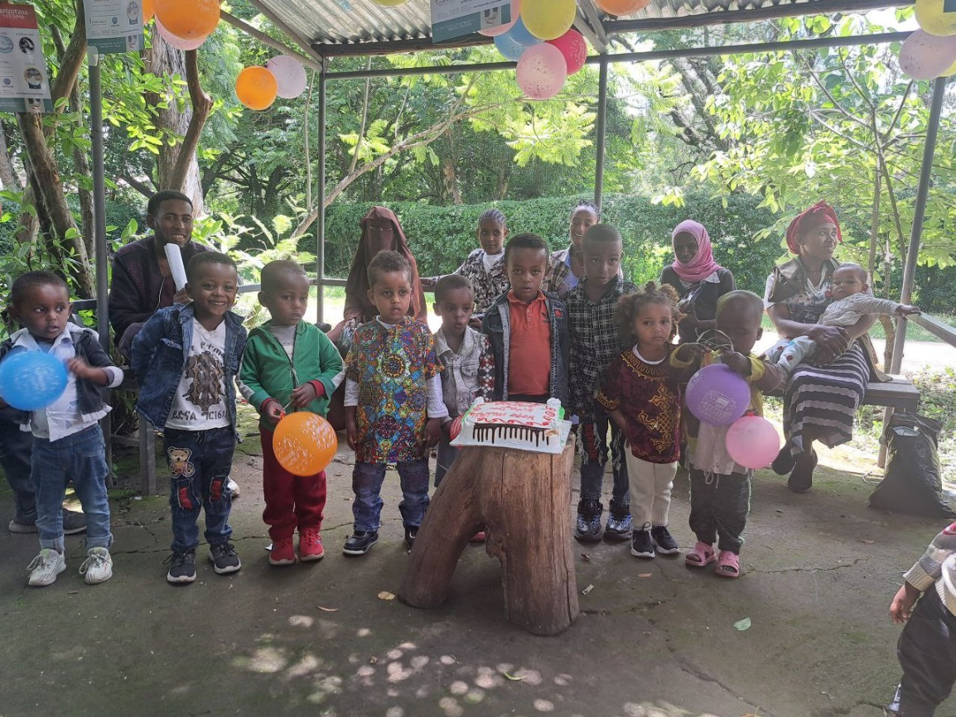

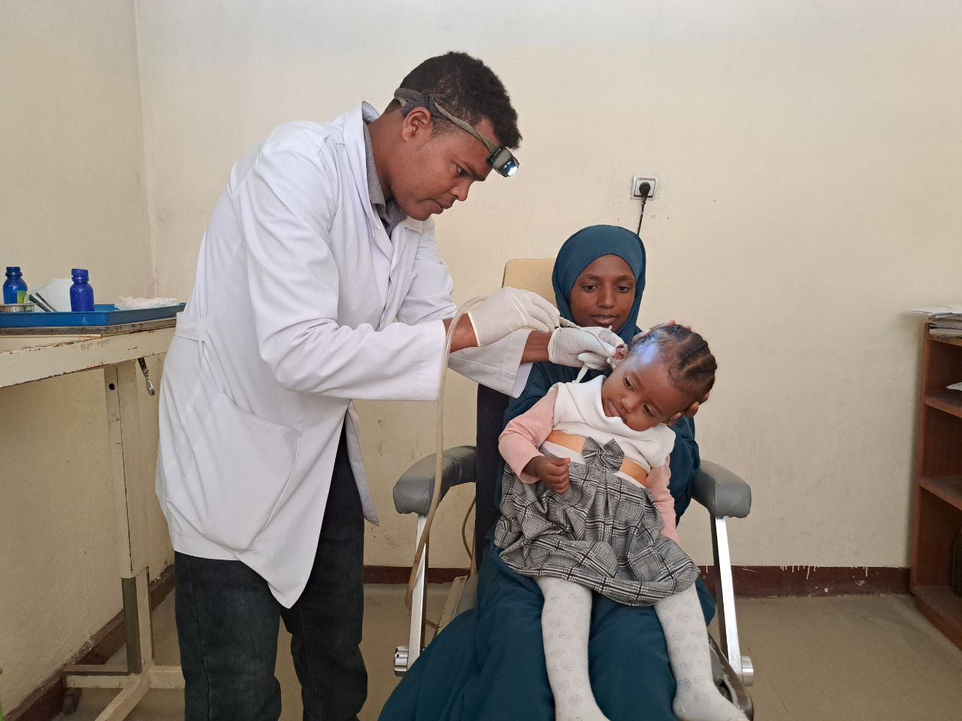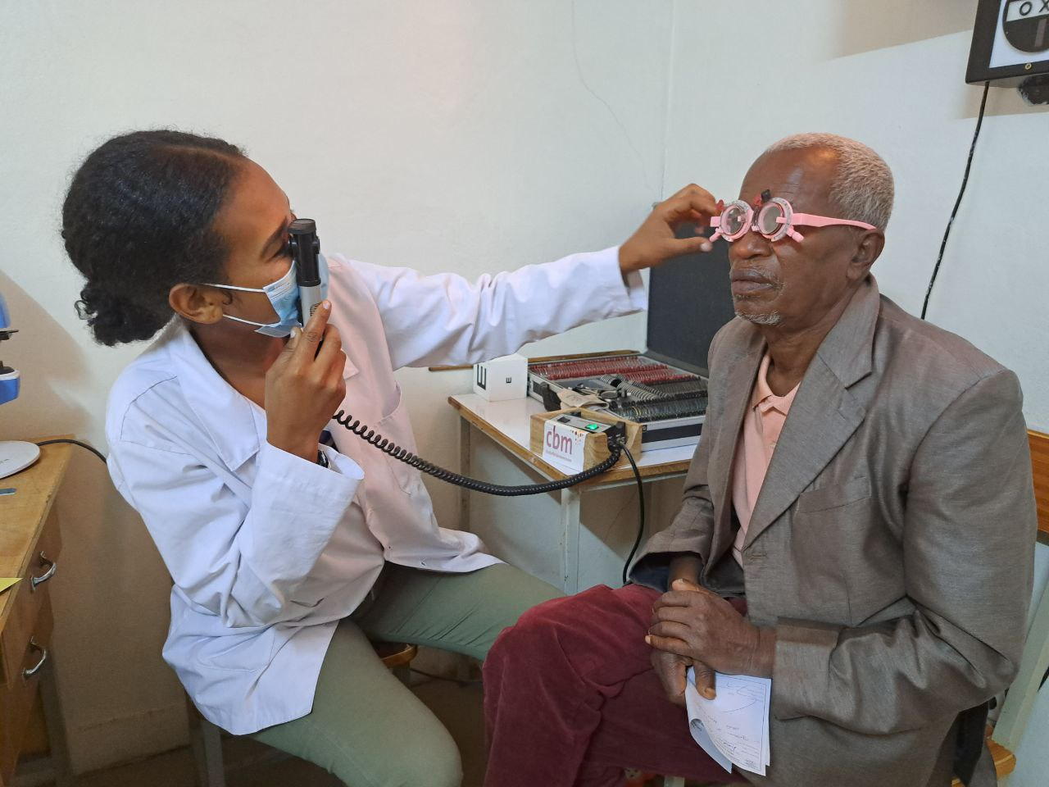

Figure GTM senior optometrist providing refraction service for the elderly patient

Figure GTM Health Officer removing foreign body from the child ear

# **COMMENTS FROM CBM OFFICE**

GTM is one of the strongest longstanding partner of CBM CO. The project under implementation is at its final year of implementation in achieving the objectives of the comprehensive medical and rehabilitation project, which is aimed at improving the efficiency and effectiveness of Comprehensive Eye Care, ENT, Epilepsy and Physical Rehabilitation Services addressing persons with disabilities and at risk of disability in Butajira Specialized hospital. The targeted beneficiaries are from the rural and central Ethiopia in Southern Nations and Nationalities People Region, and the neighboring Oromia Region. They include women, man, boys and girls and person with disabilities. In the biannual reporting period, the partner is able to continue to implement most of its planned activities as per its schedule and budget, and quality. Therefore, it is able to achieve most of the result areas: Result 1: Quality eye care services provided. Result 2: Essential ENT services provided to rural people in central Ethiopia. Result 3: Locomotors rehabilitation services provided to persons with disabilities, and Result 4: Medical services provided to patients with Epilepsy in rural central Ethiopia. Therefore, during this period as it indicated in the narrative report significant number of the targets in the plan have been reached with different services. Some photos of services have been provided below. Project implementation has been followed up and supported regularly from CO side through phone conversation and email communication. No M&E visit was conducted in this period. However, the 1st M&E visit is planned in August,2023.

Notwithstanding, it was challenged with some factors such as unavailability of medicines for epilepsy patients and hearing aids as well, and high patient load in the waiting list in need of surgical intervention in Ear and hearing care. Dr. Uta the ENT surgeon from Saint Paul Hospital Millennium Medical College in Addis Ababa conducts the Outreach services for surgical intervention twice a year at Butajira. Besides, provision of Low vision services was also challenged because of shortage of budget.

Reports are delivered timely with standard quality. Three reports (finance report, narrative report and Statistics report) are reviewed and feedback given and the partner reacted and revised to send it back timely as per the feedback. In general, the partner would continue to achieve its planned result with continued support from the CO.

-End of document. Back to top-